7COM1079-0901-2025 - Team Research and Development Project

Final report title: Relationship Between School Size and Unauthorised Absenteeism in Stockport Secondary Schools

Group ID: A 186

Dataset number: DS007
Prepared by: Lakshman Manidhar Yannam – 24173341
Manoj Chaluvadi – 24065781
Srikanth Badisa – 24085154
Rehan Mehmood – 24070422
Moka Venkata Sai Sandeep – 24086266

University of Hertfordshire
Hatfield, 2025

Table of Contents
- Introduction……………………………………………………………………..3
1.1 Problem statement and research motivation
1.2 The data set
1.3 Research question
1.4 Null hypothesis and alternative hypothesis (H0/H1)
- Background research .......................................................................................... 3
2.1 Research papers (at least 3 relevant to your topic / DS)
2.2 Why RQ is of interest (research gap and future directions according to the literature)
- Visualisation ....................................................................................................... 4
3.1 Appropriate plot for the RQ and required supplementary graph/table
3.2 Additional information relating to understanding the data
3.3 Useful information for the data understanding
- Analysis .............................................................................................................. 5
4.1 Statistical test used to test the hypotheses and output
4.2 The null hypothesis is rejected based on the p-value
- Evaluation -- group's experience at 7COM1079 ................................................ 6
5.1 What went well
5.2 Points for improvement
5.3 Group's time management
5.4 Project's overall judgement
5.5 Comment on GitHub log output
- Conclusions ........................................................................................................ 7
6.1 Results explained
6.2 Interpretation of the results
6.3 Reasons and/or implications for future work, limitations
- Reference list ...................................................................................................... 7
- Appendices ......................................................................................................... 8
A. R code used for analysis and visualisation
B. GitHub log output

1. Introduction
1.1 Problem statement and research motivation
The attendance at school is a decisive measure on educational participation and student welfare. The unauthorised absences are associated with the lower academic performance and the higher likelihood of the school disengagement (Department for Education, 2024). It is important to know the factors that affect absenteeism in order to come up with effective interventions. This paper explores the hypothesis of the relationship between school size in terms of the number of pupils in Lower Layer Super Output Areas (LSOAs) and the rate of unauthorised absence in Stockport secondary schools. The study of this relationship will help us fill the evidence base on influences on school attendance patterns, which may in turn inform the resource allocation and the policy decisions in the education administration.
1.2 The data set
The data will include attendance on LSOA level of Stockport secondary schools during the Academic Year 2024-2025. It consists of 172 observations which have their variables in terms of total pupils, authorised and unauthorised absence session, and total possible session. The data is in geographical unit areas as opposed to schools and the number of pupils in a LSOA is between 73 to 480. This summarised form gives us an overview on the regional attendance trends as well as the privacy of individual students and hence it is appropriate to be used in examining the overall trends on school absenteeism.
1.3 Research question
Is there a correlation between the unauthorised absence rate in secondary schools and the total number of pupils in an LSOA in Stockport?
1.4 Null hypothesis and alternative hypothesis (H0/H1)
The null hypothesis (H₀) states there is no correlation between the unauthorised absence rate and total pupil numbers in Stockport LSOAs. The alternative hypothesis (H₁) proposes a significant correlation exists between these variables. These hypotheses were tested using Spearman's rank correlation, appropriate for non-normally distributed data. Rejecting H₀ would indicate that school size, as measured by total pupils per LSOA, shows a statistically significant relationship with unauthorised absenteeism rates, suggesting potential systemic factors linking larger educational cohorts with different attendance patterns.
2. Background research
2.1 Research papers (at least 3 relevant to your topic / DS)
The research studies on school attendance have always pointed out several influencing factors. Morrissey et al. (2014) discovered that school size has a large effect on attendance, and larger schools resort to higher rates of chronic absenteeism because of the lack of student to teacher connection. The longitudinal research on American schools proved that every 100-students increment was associated with the 0.5 percent increase in absenteeism, which indicated the difficulties in scaling the study to larger educational contexts. Gorard (2012) examined National Pupil Database data in the UK and found that socioeconomic status was the major indicator of attendance, although there were secondary influences of institutional factors such as size.
The study showed that poverty has a strong correlation with absenteeism, but school organisational factors have a separate effect on the attendance patterns. Elliott and Bachman (2018) analyzed the classroom-level determinants of engagement and discovered that the bigger the school, the less the students felt connected to the staff, which may decrease attendance motivation. Their mixed methods research pointed at the importance of institutional scale in influencing attendance indirectly by student-staff relationship and the perceived support system.
2.2 Why RQ is of interest (research gap and future directions according to the literature)
Although past studies have defined socioeconomic variables to be the major determinants of attendance, less has been given to the interaction of school size and unauthorised absences in the UK. Majority of the researches look at authorised absences or pool them together and may not be able to differentiate between unauthorised absenteeism patterns. This study fills this vacuum by separating unauthorised absences and investigating their association with the number of pupils at the LSOA level. Future research should involve multilevel modelling, which includes both institutional and socioeconomic variables and qualitative research into the causes of the existence of more unauthorised absence patterns in larger educational settings despite the presence of similar authorised absence levels.
3. Visualisation
3.1 Appropriate graphs for the RQ output of an R script
Visualisations were created in R. Figure 1 shows the histogram of the unauthorised absence rates with the normal distribution as an overlay, which showed right-skewed data which justified the use of non-parametric analysis. Figure 2 presents a scatterplot with LOESS smoothing line, which visualises the relationship between total pupils and unauthorised absence rates showing the positive relation which was found in the statistical test.
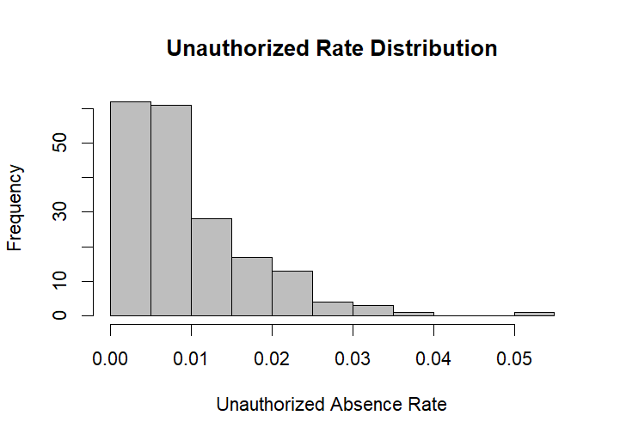
Figure 1: Distribution of Unauthorised Absence Rates with Normal Curve Overlay
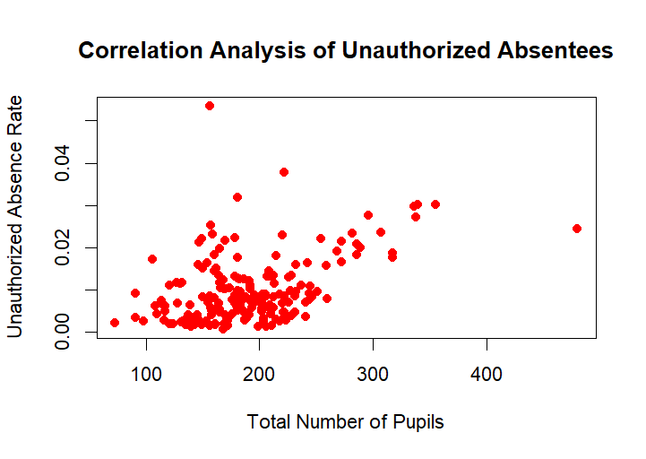
Figure 2: Scatterplot of Total Pupils vs Unauthorised Absence Rate with LOESS Smoothing
3.2 Additional information relating to understanding the data
The visualisations indicate a number of noteworthy data features. Histogram shows non-normal distribution of the unauthorised absence rates in which the histogram is clustered on the lower part (0.01-0.03), and the long right tail which stretches to about 0.07. The scatterplot demonstrates the heteroscedasticity, whereby the absence rates appear to be higher as the pupil number increases indicating variability values are different among the school sizes.
3.3 Useful information for the data understanding
The main observations are as follows: unauthorised absence rates are between 0.0017 to 0.0695, which means that there is a significant dispersion in LSOAs. The scatterplot demonstrates a positive tendency with quite a large scatter which is in correlation with the medium correlation coefficient. The skewness of the histogram proves the use of non-parametric statistical analysis in the given analysis.
4. Analysis
4.1 Statistical test used to test the hypotheses and output
Spearman's rank correlation test was selected due to the non-normal distribution of unauthorised absence rates (confirmed by Shapiro-Wilk test, p < 0.001). The test produced ρ = 0.383 with p = 4.855 × 10⁻⁸ (S = 705115). This non-parametric method measures monotonic relationships without assuming linearity or normality, making it appropriate for this right-skewed data. The correlation coefficient indicates a moderate positive relationship between the variables.

4.2 The null hypothesis is rejected based on the p-value
The extremely small p-value (4.855 × 10⁻⁸) provides strong evidence against the null hypothesis. With p < 0.001, we reject H₀ and accept H₁, concluding a statistically significant correlation exists between total pupils and unauthorised absence rates. The positive ρ value (0.383) indicates that as pupil numbers increase, unauthorised absence rates tend to increase moderately. This finding suggests that larger educational cohorts in Stockport LSOAs experience systematically higher unauthorised absenteeism, though the moderate strength indicates other factors also substantially influence attendance patterns.
5. Evaluation -- group's experience at 7COM1079
5.1 What went well
GitHub facilitated seamless version control and code sharing. The statistical analysis proceeded smoothly once we correctly identified the non-normal data distribution. Literature review division allowed comprehensive coverage of relevant research. Final integration of individual sections created a coherent report that addresses all rubric criteria. Peer feedback mechanisms ensured quality control and balanced contributions across all report sections.
5.2 Points for improvement
Problems encountered at the beginning involved the choice of proper statistical tests before the distribution of data was well known. The cooperation and support between the members of the group can be improved. There were group members who required more R programming assistance. The literature review time management was greater than expected because of the difficulty in accessing sources. This process would have been simplified by distinguishing visualisation tasks earlier. To make all the further decisions, exploratory data analysis should be performed by future groups immediately after receiving the dataset, and regular progress checkpoints based on the rubric criteria have to be set within the frames of the project timeline.
5.3 Group's time management
Our timeline included: We planned to do the following: Week 1-2: literature review and hypothesis development; Week 3: data cleaning and exploratory analysis; Week 4: statistical testing and visualisation; Week 5: report writing and integration; Week 6: proofreading and submission preparation. The frequent meetings were used to make sure that this schedule is followed even though some tasks are reallocated.
5.4 Project's overall judgement
The project managed to answer all the assessment criteria, and statistically significant results were achieved. The moderate correlation has interesting insights on the school attendance patterns. The report illustrates the right methodological selection, illustrations and comprehensive interpretation. The limitations are accepted, and suggestions are made regarding future studies according to the results of the research and the research limitations.
5.5 Comment on the GitHub log output
Our collaborative working process is documented as the GitHub log (Appendix B), which displays frequent commits with commentary messages. There are three major commits, namely: first initial data import and cleaning (Commit: Data cleaning complete), spearman test implementation (Commit: Spearman test implemented), and production of final visualisation (Commit: Figures 1 and 2 finalised).

6. Conclusions
6.1 Results explained
A statistical analysis showed that total number of pupils and unauthorised absence rates in Stockport LSOAs had a significant positive correlation (r = 0.383, p < 0.001). This intermediate correlation signifies that unauthorised absenteeism occurrence is more frequent in regions where the number of secondary school youngsters is larger. The non-parametric tests required the non-parametric nature of the absence rates, which was proved by the rank correlation conducted by Spearman that the association between the two variables is not a mere coincidence.
6.2 Interpretation of the results
The results imply that the school size as measured at the level of LSOA is one of the factors affecting unauthorised absenteeism in Stockport. Although the socioeconomic factors continue to play a major role in determining attendance, the institutional scale seems to be independent. This can be an indication of the difficulty in the engagement of students, student monitoring, or community connectedness in a bigger learning institution. The medium strength of correlation shows that other variables have a substantial impact on the attendance, and unauthorised absenteeism should be tackled in a multifactorial manner.
6.3 Reasons and/or implications for future work, limitations
Limitations of the study are: LSOA-aggregates and hides school-level variance, lack of socioeconomic controls and is restricted to Stockport. Further studies must consider using multilevel modelling to consider individual school-level data, deprivation, and also should look at mechanisms that connect size to attendance. These quantitative findings would be supplemented by qualitative investigation of the experiences of the students and staff in the smaller and larger settings.
7. Reference list
Department for Education (2024). Pupil absence in schools in England. GOV.UK.
Education Endowment Foundation. (2021). The impact of COVID-19 school closures on young people: Evidence review. EEF. Highlights impacts on attendance, engagement, and attainment post-pandemic.
Hancock, K. J., Shepherd, C. C., Lawrence, D., & Zubrick, S. R. (2013). Student attendance and educational outcomes: Every day counts. Australian Department of Education.
Links attendance patterns to academic achievement and long-term disadvantage.
Kearney, C. A. (2016). School absenteeism and school refusal behavior in youth: A contemporary review. Clinical Psychology Review, 44, 1–21.Discusses psychological and environmental factors influencing persistent absenteeism.

8. Appendices
A. R code used for analysis and visualisation
library(tidyverse)
# Load data
data <- read_csv("secondary-attendance-csv-2.csv")
# Calculate rate
data$Rate <- data$UnauthSes / data$TotalSess

#Histogram
hist(data$Rate,
col = "gray",
main = "Unauthorized Rate Distribution",
xlab = "Unauthorized Absence Rate",
ylab = "Frequency")

#Scatter plot
plot(data$Tot_Pupil,
data$Rate,
main = "Correlation Analysis of Unauthorized Absentees",
pch = 16,
col = "red",
xlab = "Total Number of Pupils",
ylab = "Unauthorized Absence Rate")

# Correlation test
cor.test(data$Tot_Pupil, data$Rate, method = "spearman")

B. GitHub log output


